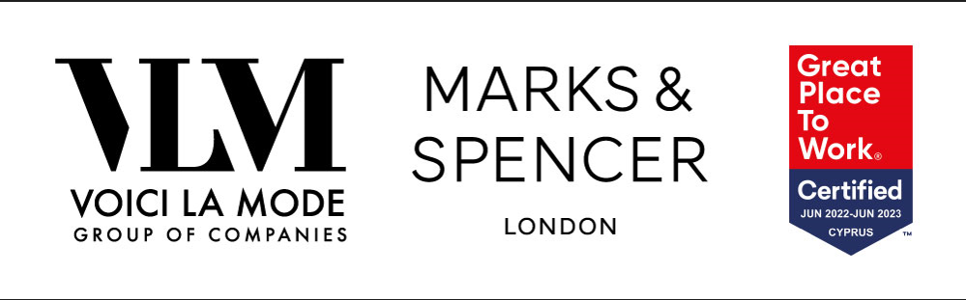

Human Resources Executive for Marks and Spencer Stores in Nicosia

Our people are the heart of our success. Caring for our people and giving them the opportunity and support to grow and develop are values embedded deep in our culture.
The Environment we work in is dynamic and fast-paced and our HR Team is key in making things work. We are looking to recruit a highly motivated individual with a hands-on HR Management style, pleasant personality and can do attitude, who enjoys working in a dynamic and fast-paced environment, to join our HR Team and have the responsibility for looking after the people in our Marks & Spencer stores.

Responsibilities

- Assist in the development and implementation of human resource policies and procedures
- Handle employment issues and ensure the compliance of stores with the relevant legislations
- Provide specialist personnel support and advice to Store Management and staff
- Ensure a motivated and supportive working environment through guidance and conflict resolution
- Deliver training to Staff and monitor their performance
- Manage staff cost

Requirements

- At least 3 years of experience in an HR Management related role
- University Degree in Human Resources Management or a related field will be considered an advantage
- Experience in the retail industry will be considered an advantage
- Excellent interpersonal and communicational skills
- Dynamic, self-motivated and results driven
- Ability to work independently with minimum supervision
- Customer Service Driven
- Very good knowledge of Greek and English language

Benefits
An attractive remuneration package will be offered to the successful candidate according to qualifications and experience.

Applications
Please apply online at https://voicilamode.com/careers/ or send your CV at jobapplication@voici-la-mode.com with the Reference code HR/S/HR01
Please note that only successful candidates will be contacted.

